Database System Engineering and Distributed Backend Development
Course Code: 25CS13002E
WEEK-2
ROLL NO:2520030177
NAME: P.Harini
Query1: Create Database
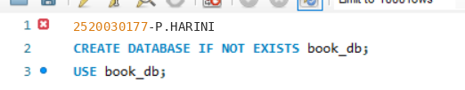
Output:

Query 2: Create Books Table (DDL + Constraints)
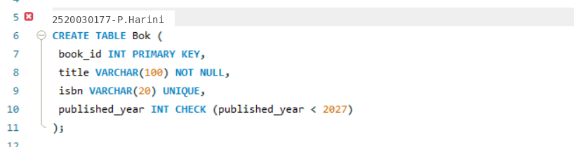
Output:

Query 3: Insert Books
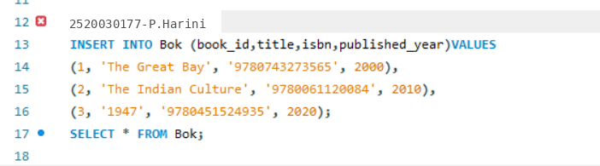
Output:
Query 4: Display
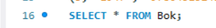
Output:
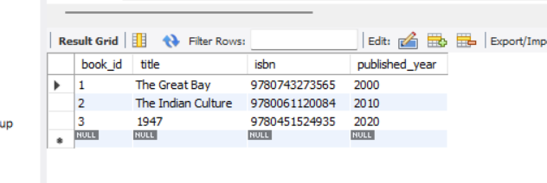

Query 5: Members Table: Create
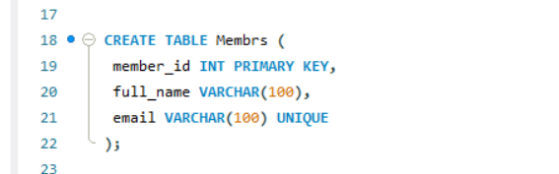
Output:

Query 6: Insert Members table
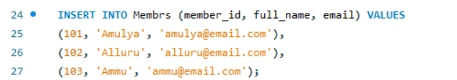
Output:

Query 7: Display Members table
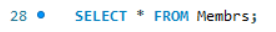
Output:
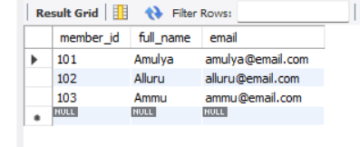

Query 8: Create Loans Table
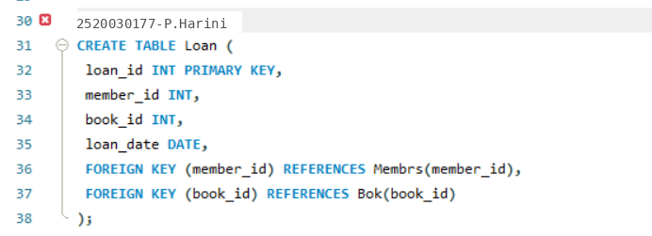
Output:

Query 9: Insert 10 Loans
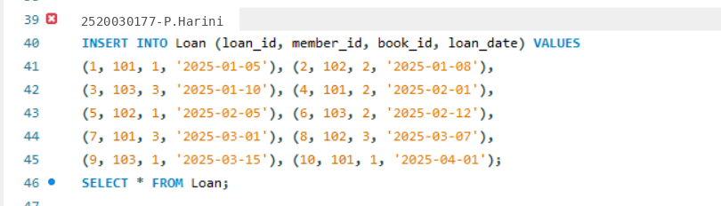
Output:

Query 10: Display
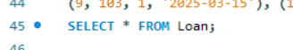
Output:
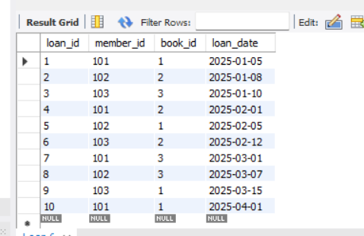

Query 11: JOIN Query
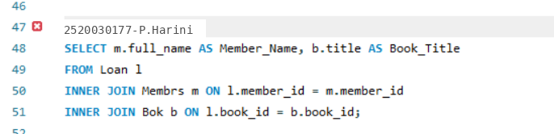
Output:
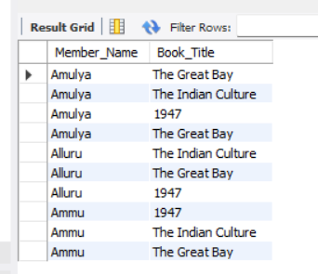

Query 12: GROUP BY Query
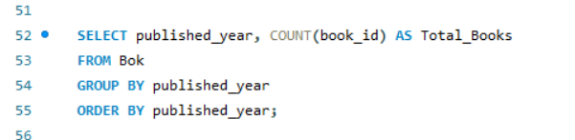
Output:
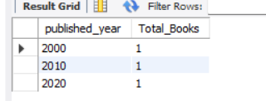

Query 13: Donation via TRANSACTION
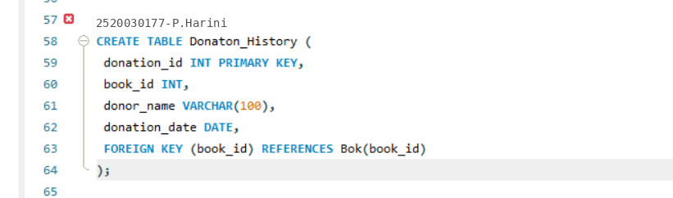
Output:

Query 14:
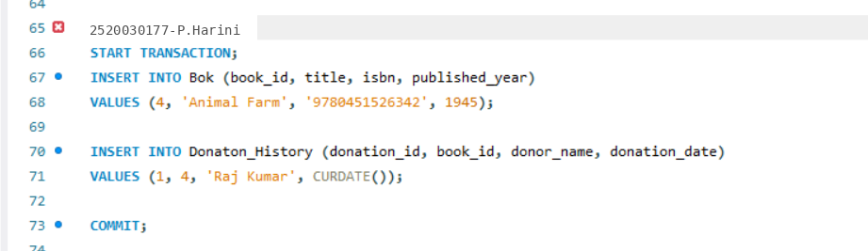
Output:

Query 15: Index on ISBN
Output:

Query 16: Fast Search
Output:
